MC900058218[1]

**1st Quarter**

**2019-2020**

**8th Grade Newsletter**

**Nathan Hale School**

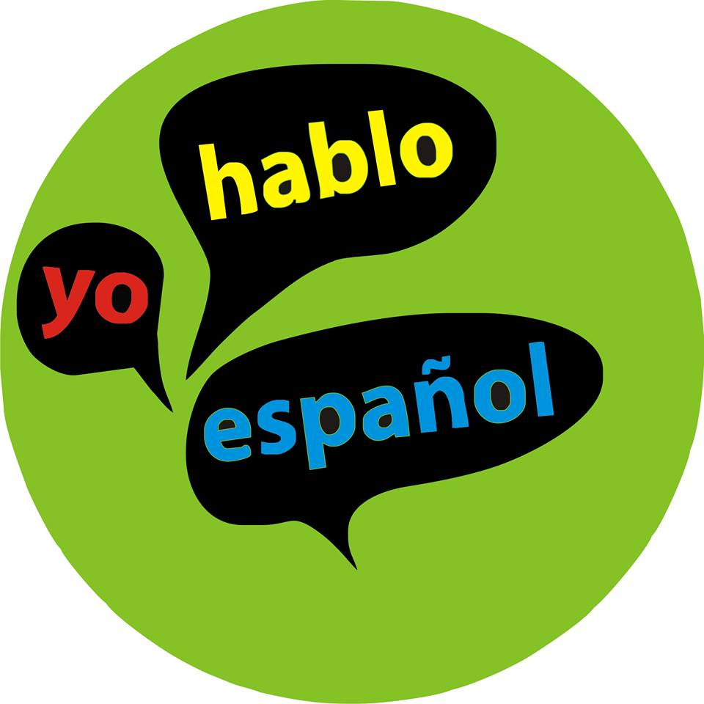

**Spanish 1B**

During this unit, students will learn how to talk about the aspects of homes and families that are most relevant to their daily lives – Who their family members are and what they do at home. This might include chores or leisure activities, such as eating, cleaning or watching T.V.   Students will view photos and videos of homes and families in the target culture, considering various definitions of family and “home” in different cultures.  If students wish, they will be able to create imaginary families or “dream” homes, or discuss their actual families.

The assessments require students to use the language in authentic ways, such as how you would talk on the telephone about your family members, or how you might introduce your family and home in a pen pal letter.  The unit itself begins with students working in groups to “get the gist” of a pen-pal letter from a peer in the target culture.   Languages may differ slightly in their overall vocabulary and grammar addressed in this unit, but all students will complete the unit knowing how to read, write, and talk about the basics in the topic of “home and family.”



**Spanish 1A**

During this unit, students will be exposed - many for the first time - to the geography and culture of this new language. They will view a variety of photos, videos, and realia to introduce the culture and country (ies) where the language is spoken. They will become familiar with the basics of initial social interactions and daily life, such as weather, seasons, and dates on the calendar. Students will learn how to operate in a classroom taught in the target language by understanding basic commands and necessary classroom supplies. A number of smaller assessments will help students to see their quick progress and reinforce the many new concepts learned in this initial unit. The assessments will revolve around four major areas: social interactions, calendar, weather, and culture/country(ies.)

Mrs. Anderson

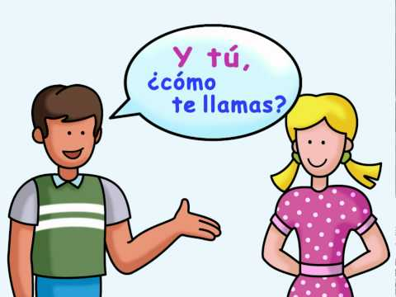

**Spanish 2**

During this unit, students will apply their prior knowledge from Level I and use a new learning about past time expressions and actions to talk about where they went and what they did over the summer and on past vacations.  They will listen to and/or watch presentations about travel and activities in a target language country/region and respond to questions about what they’ve heard.  They will read blogs about summer vacation experiences from the target culture and respond to questions about that information. They will use their knowledge of dates, weather, clothing, activities, numbers, foods/meals, and country/city names to create, understand and respond to travel postcards about real or imaginary past summer trips. They will verbally express events and activities that they participated in over the summer and respond to classmates’ questions about those experiences in an interview format. Finally, each student will present a favorite summer experience to the class using a piece of realia or memorabilia and including multiple details such as the date, place, activity, companions and reasons why the experience was so enjoyable. They will respond to clarifying questions and comments from their audience with appropriate target language information and/or expressions.

Mr. Cacopardo



**Algebra 1**

Students will be building linear models and using them to study functions, domain, and range. Linear models are the foundation for studying slope as a rate of change, intercepts, and direct variation.

Students will learn to write linear equations given varied information and express these equations in different forms.



Pre-Algebra:

In this unit students continue to develop their fluency with number concepts and extend their knowledge of number systems to the irrational numbers. They investigate patterns, powers, roots, and scientific notation, and use their understanding to solve problems.

Mr. Evans



**American History:**

8th grade American History students will be learning about life in the 13 original English colonies. Students will understand how each colony was established, and why people were attracted to a particular region. We will also focus on the economy of each colony so that students understand how important the natural resources were to the development of each colony’s wealth.

After learning the background of the 13 original English colonies, the students will be prepared to study how the French & Indian War erupted and following that, the reasons behind the colonies declaring their independence and fighting the American Revolutionary War. We will spend some time understanding the Declaration of Independence document, so that students are aware of its great importance to the country and to the world.

**An essential question you might want to ask your child is:**

What would have happened to the signers of the Declaration of Independence, if the Americans hadn’t won the war, and why were they willing to take the risk of signing it?

Mrs. Carder



**Science:**

Welcome to 8th Grade Science! I look forward to sharing science concepts with each student. Students were sent home with a rules and regulations form regarding what our expectations are. We will be discussing forces (Newtons) and bridge types and strengths. We will determine how to calculate the speed, velocity and acceleration rates of moving objects. We will study Newton's Laws of Motion and review simple machines.. We will also practice using the Scientific Method.  Students will determine independent and dependent variables as well as control variables and decide how to ask testable questions in science.  We will use current events (such as Hurricane Dorian) to introduce science literacy.

**Hot Question:**

What are some of the factors that went into the design of the NEW “Q” Bridge (Pearl Harbor Memorial Bridge)?

Mrs. Gallagher



*As a special note: Ms. Bellmore will have a student teacher, Ms. Jones, through early December. Ms. Jones will be at our annual Open House to meet with parents personally.*

**Reading**

In Reading, students will begin out fiction work with Rick Riordan’s *The Lightning Thief*, a fantasy novel that allows students to explore Greek mythology. Our work will primarily be done together, although students will have some work with the novel as homework. In our reading, students will complete various reading tasks to help visualize and synthesize their reading. Students will continue completing weekly responses to their reading, using text evidence to ground their thinking about their reading.

HOT Questions to Discuss: 1) Consider some of the Greek myths you’ve learned about. What kind of messages are the Greek myths trying to communicate? 2) If you discovered you were a “half-blood,” what would you hope your powers would be and why? 3) How does Percy develop as a leader from the beginning of the book through his dramatic and dangerous journeys?

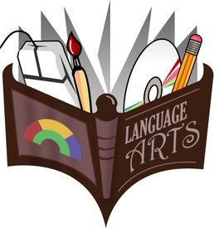

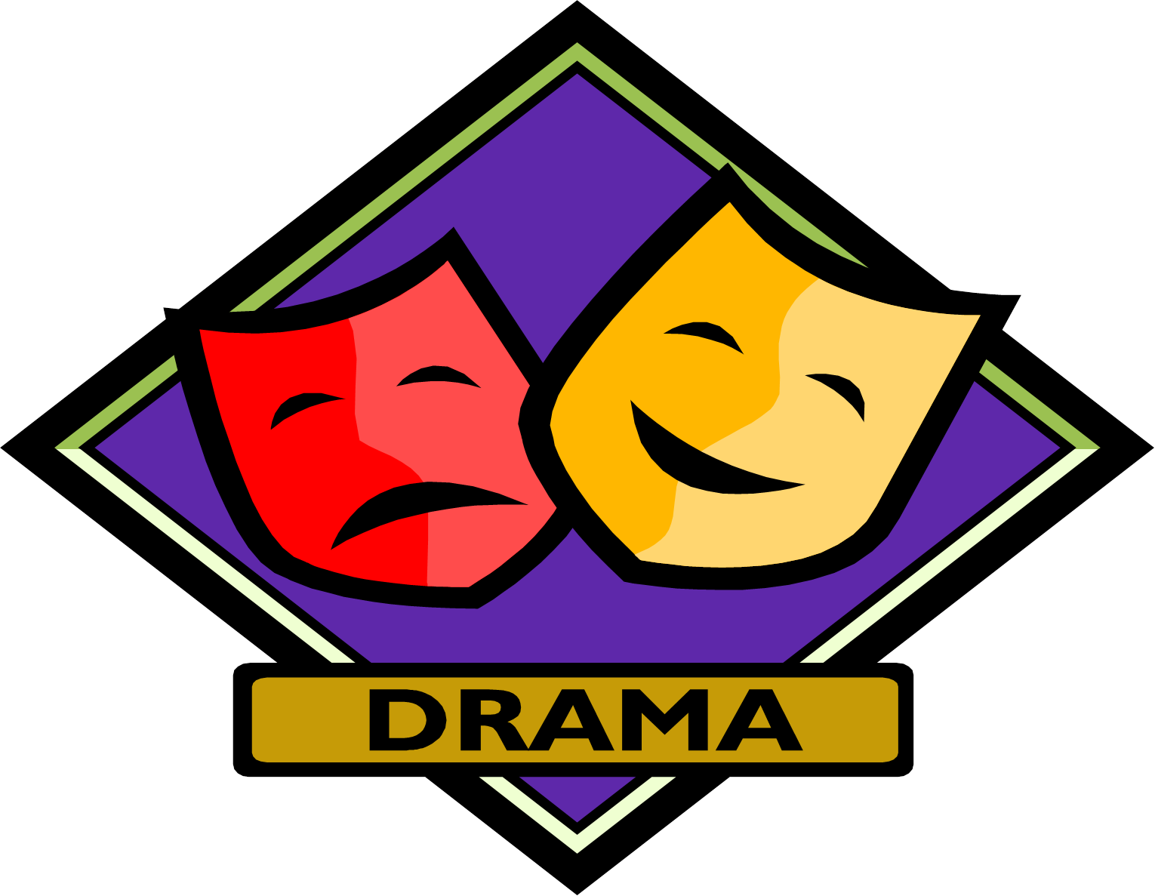

In Drama, 8th grade students will focus exclusively on drama as a literary genre. Our first text in this endeavour will be Thornton Wilder’s *Our Town*. Through this play, students will begin their analysis of structure in this literary style, an analysis that will continue throughout the year. Moreover, students will work on taking the play off the page by creating elements of a production design for *Our Town* to demonstrate their understanding of Wilder’s characters, settings, and themes. Lastly, and picking up on work Drama students did last year in Advanced, these students will continue using annotations, reading logs, and weekly responses to literature develop mastery of this genre in literature.

HOT Questions to Discuss: 1) Can you describe Grovers Corners? What does it look like? What are its people like? 2) What is a theme of *Our Town* and how can you support that with evidence from the text?



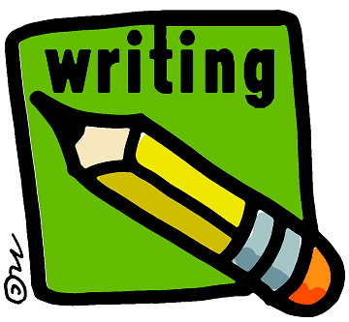

**Writing:**

Welcome back (and welcome to Nathan Hale for our students who have transferred in); we are excited to get started!

**Language Arts** classes will have plenty of time to devote to reading, writing and thinking skills. As a thematic focus for the year, students will consider the following questions: Who am I? With what or who do I identify most? What do I love about myself? How do people in my family see me? How does the world see me? How can I learn about myself by reading about the lives of others? We will read one major text together per quarter, while also reading our own independent choice books throughout the year. Students will participate in reading workshop, Socratic Seminar, language study, and writer’s workshop.

**8th Grade Advanced Writing Class** is focused on Writing for Action: preparing and empowering 21st students for critical thinking and civic engagement. Students will consider the questions: What do I love and care about? What of those need my help or need saving? When has writing ever changed anything in the world? How can I find my voice? How can I use writing to affect change? They will understand that Language is power, and that they have the ability to harness and wield that power by studying language. They will study etymology, grammar, various genres and styles, ultimately seeking to help, change, or save something they care about by producing OpEd pieces, documentaries, podcasts, and argument essays.

Ms. Bellmore

Ms. Johnston

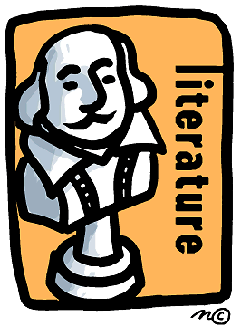



**Advanced Language Arts**

In Advanced Language Arts, students will start their work with their first fiction, *Monster* by Walter Dean Myers. Students will trace how characters develop throughout a screenplay. Students will keep a reading journal that tracks their thinking about our protagonist’s development, as well as citing direct text evidence that reveals how characterization develops through dialogue. Also, students will continue completing weekly responses to their reading, which uses text evidence to ground their thinking about their reading.

HOT Questions to Discuss: 1) What makes people in the world “outsiders”? 2) How is reading a screenplay more difficult than reading a novel?

Sept. 11: Open House 5:00-7:00 PM

Sept. 19: No School – Yom Kippur

Sept. 21: Family Picnic with Cornhole Tournament

Oct. 8: No School - Columbus Day

Oct. 22: Early Dismissal

Nov. 2: End of 1st Marking Period

Important Dates

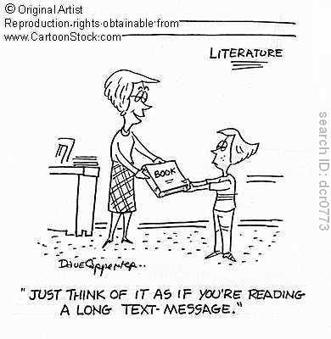

Ms. Bellmore

Developmental Pathways: Physical Language Psychological Cognitive Social Ethical